**Project Report Recipe Search Application**

CS-5560 KDM – Increment 4

**Varun Narisetty**

**Rajesh kannan Rajendran**

**Murali Krishna Kalvakuri**

**Sai Sowmya Kamaraju**

We have been able to implement the following features as part of the first, second, third and fourth increment of the project.

1. Home screen for the user to enter all the ingredients.
2. Interface screen to show the results for the entered combination of recipes.
3. Collected all the RDF datasets for recipe from the internet using web crawler.
4. We have classified datasets using naïve-base algorithm in mahout.
5. Pushed this classified data into solr.
6. Developed an Android UI in order to display the output generated after machine learning.
7. Getting the results from the Hbase and showing it to the user.

**Web Client/Mobile UI Design**

To design the UI, we have used android API, open source images, android default spinner and number picker widgets.

**System Architecture Diagram**

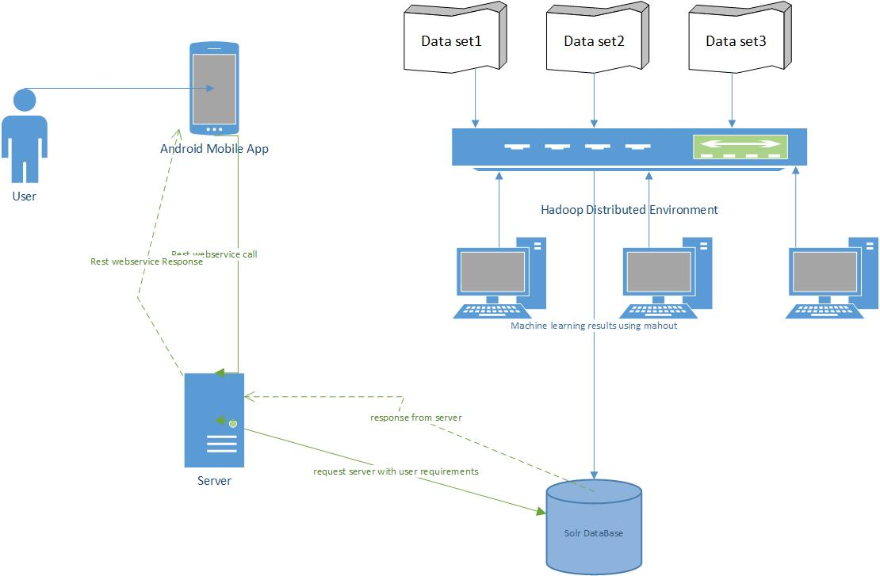

**Class Diagram**

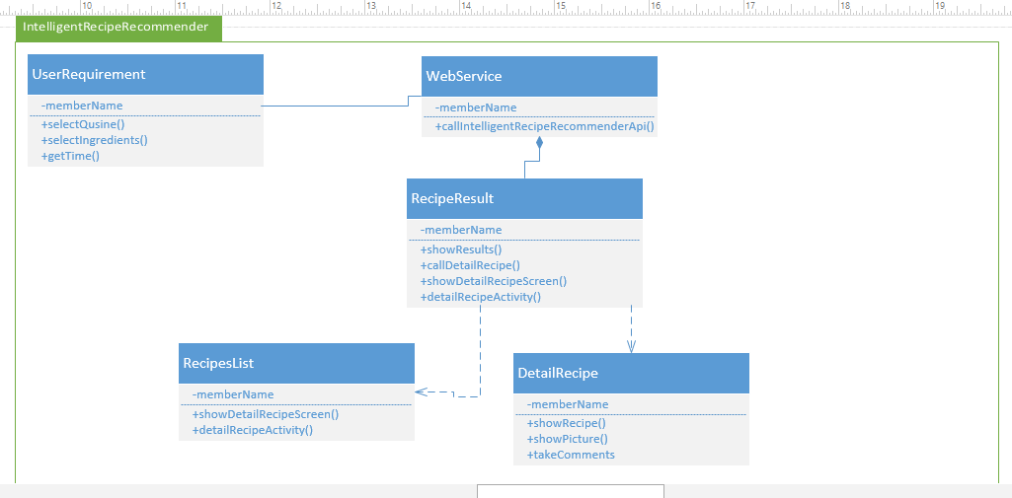

**Sequence Diagrams**



**Implementation Details**

The details of the features are below:

**Webservices/API:**

* We have used android app in order to make the home screen where the user can enter the ingredients which he have, time for making the recipe, what kind of cuisine and what kind of meal and after that we also created an android API for the result screen where we will show what kind of recipe he can make.
* **Design & Implementation details:**

Splash screen for android app



We will launch our application by clicking app icon from launcher



Screen shots for home screen of recipe recommender where we will take input from the user.

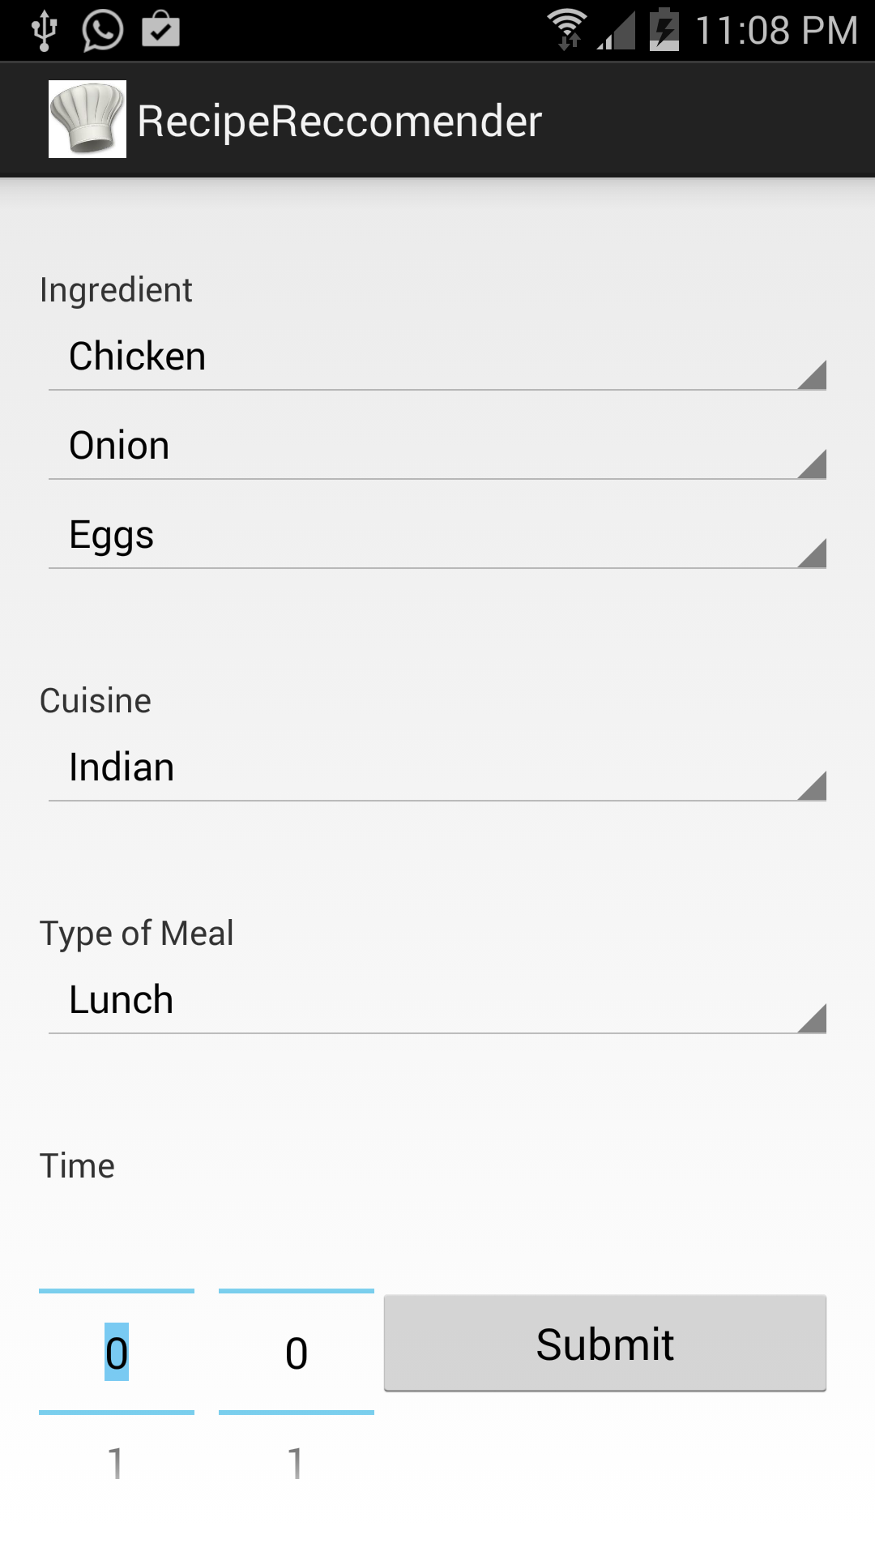

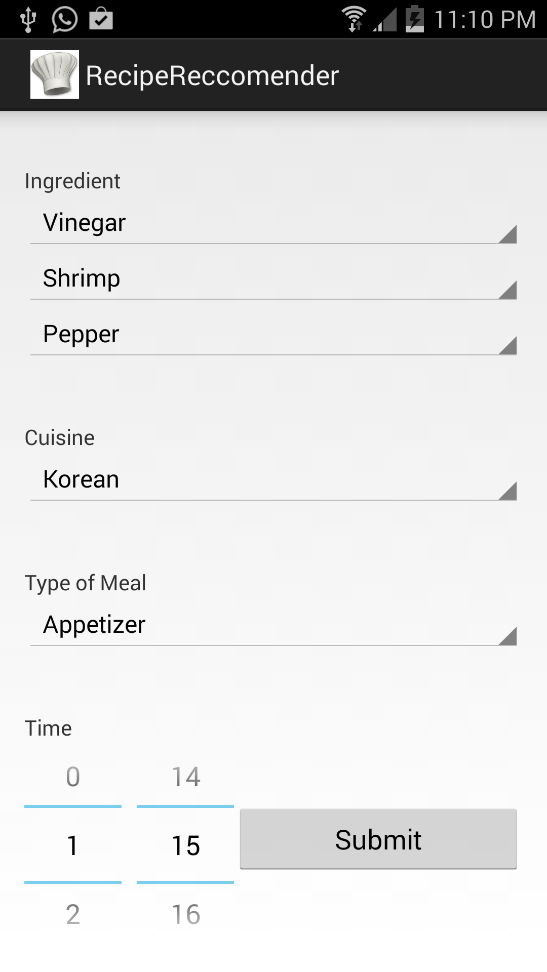

Screen shot for data sets

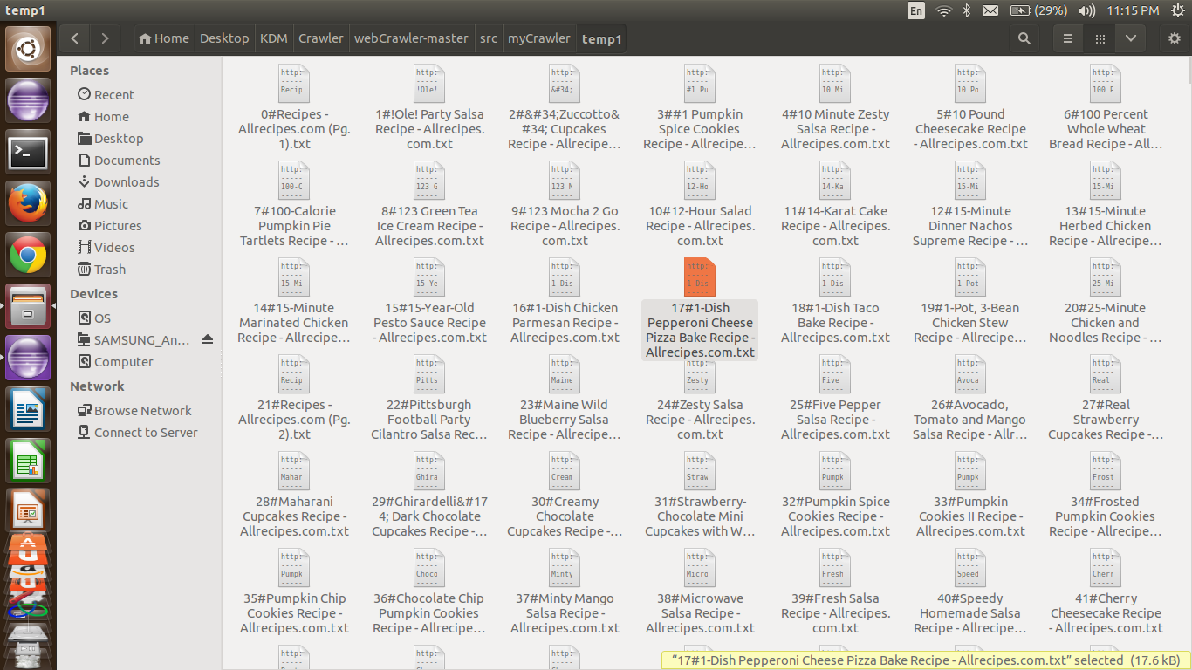

**Output after machine learning.**

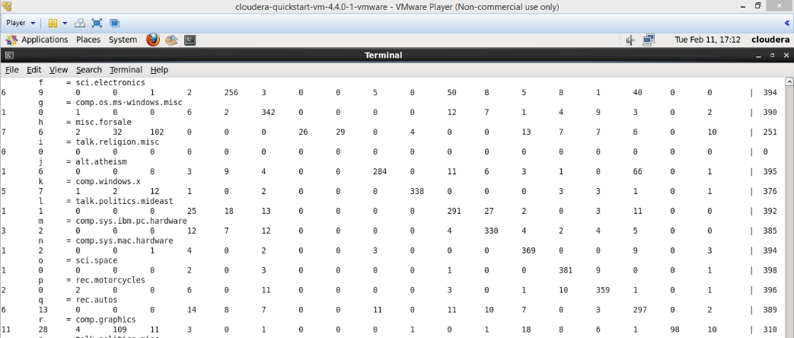

**Screen shots from Android page.**

As a part of increment-3 we updated the user’s home page with good user friendly GUI to select the ingredients from the ingredients pool. Some screen shot for that are shown below:

We completed almost 85% of the project, we are still looking for good performance and more accuracy.

For example user selects Salt, we showed it by enlarging the ingredient from the pool and it will be move right side.

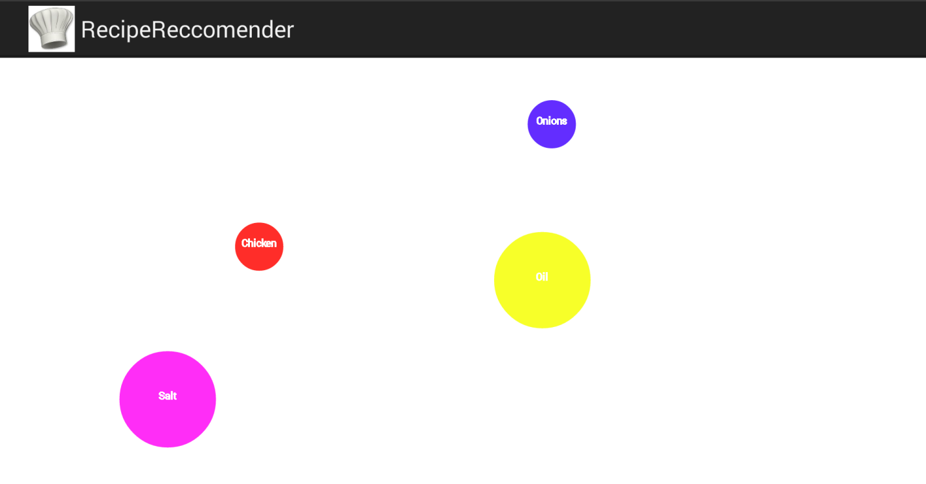

For example here the user selected Salt and Chicken as the ingredient which are enlarged and kept separately.

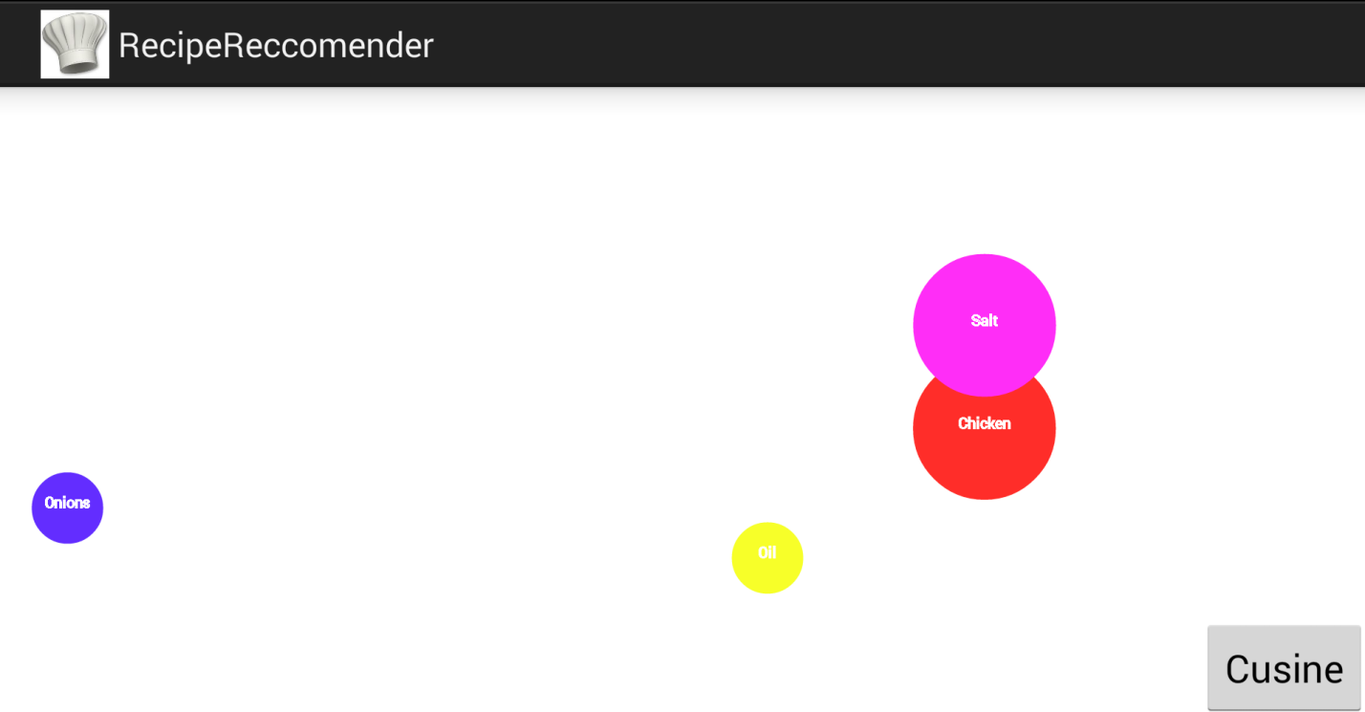

**Work Completed:**

We almost completed whole project – Recipe Recommender. We got the dataset using web crawler and we pushed the data to Hbase. We ran mahout classification system on the data and pushed to local solr. Designed the page for getting ingredients and get recommendation from solr and fetch the corresponding results from the Hbase.

**Work to be completed:**

We have to just get the results from HBase and have to dislplay it to the user.And we are looking for better accuracy and good performance.

**Contribution:**

**Varun Narisetty** – Worked on Front End Android App.

**Rajesh Kannan Rajendran** – Worked on Machine learning Mahout Recommendation system and pushed the data to HBase.

**Murali Krishna kalvakuri** – Worked on the web service part for Android App.

**Sai Sowmya Kamaraju** – Worked on Dataset extraction and data cleaning.

**Time Taken:**

For getting the data sets through web crawler it took around 30 hours. Cleaning this data as per our requirement with exact format – 10 hours. We stored the data in HBase – 8 hours. Mahout Recommendation system – 15 hours. Writing web service for Android App took 20 hours. For Android App page design - 45 hours.

1. **Fourth Increment:**

As a part of increment4, we are getting the results from the HBase and displaying it to the user. And we did some animation effect in all the pages to be more attractive. Screen shots are shown below:

1. When the user selects the ingredient, we enlarging it to make user they selected that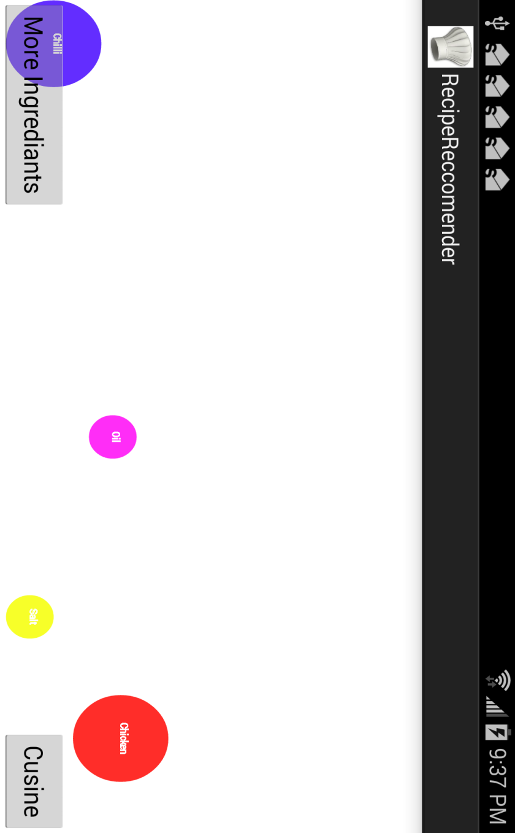
2. With these ingredients, if user clicks cusine button it will show the time taken for the particular recipe.

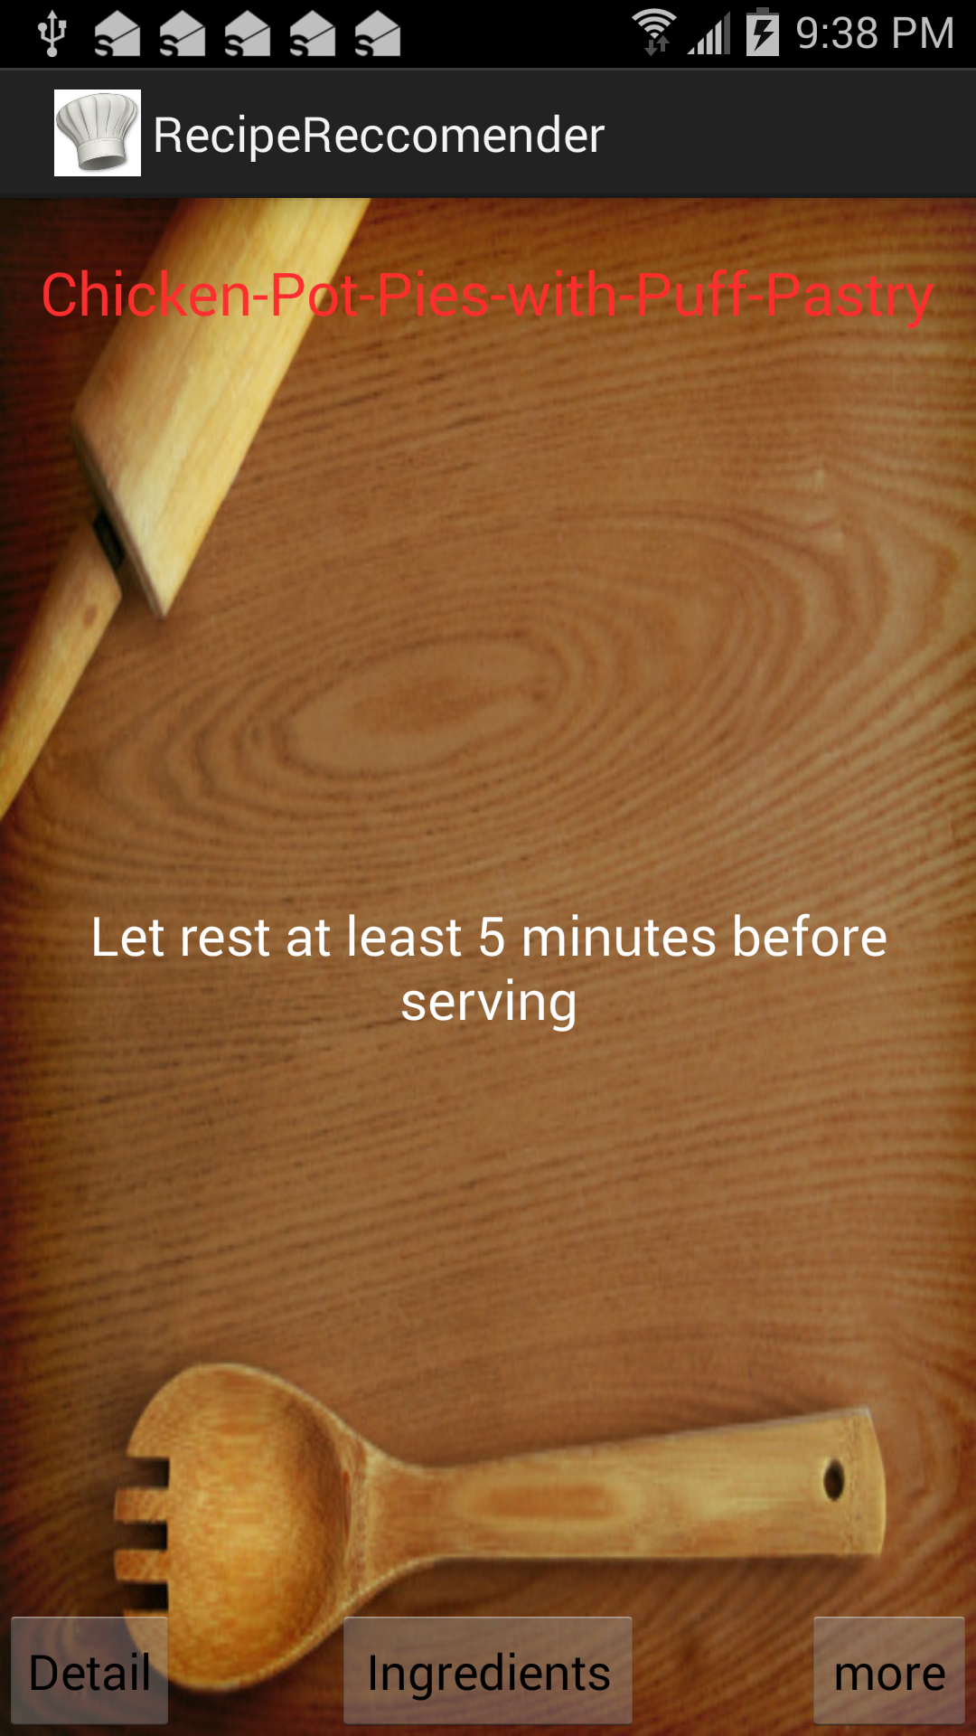 3) Then it will show what are the steps and how to make the recipe 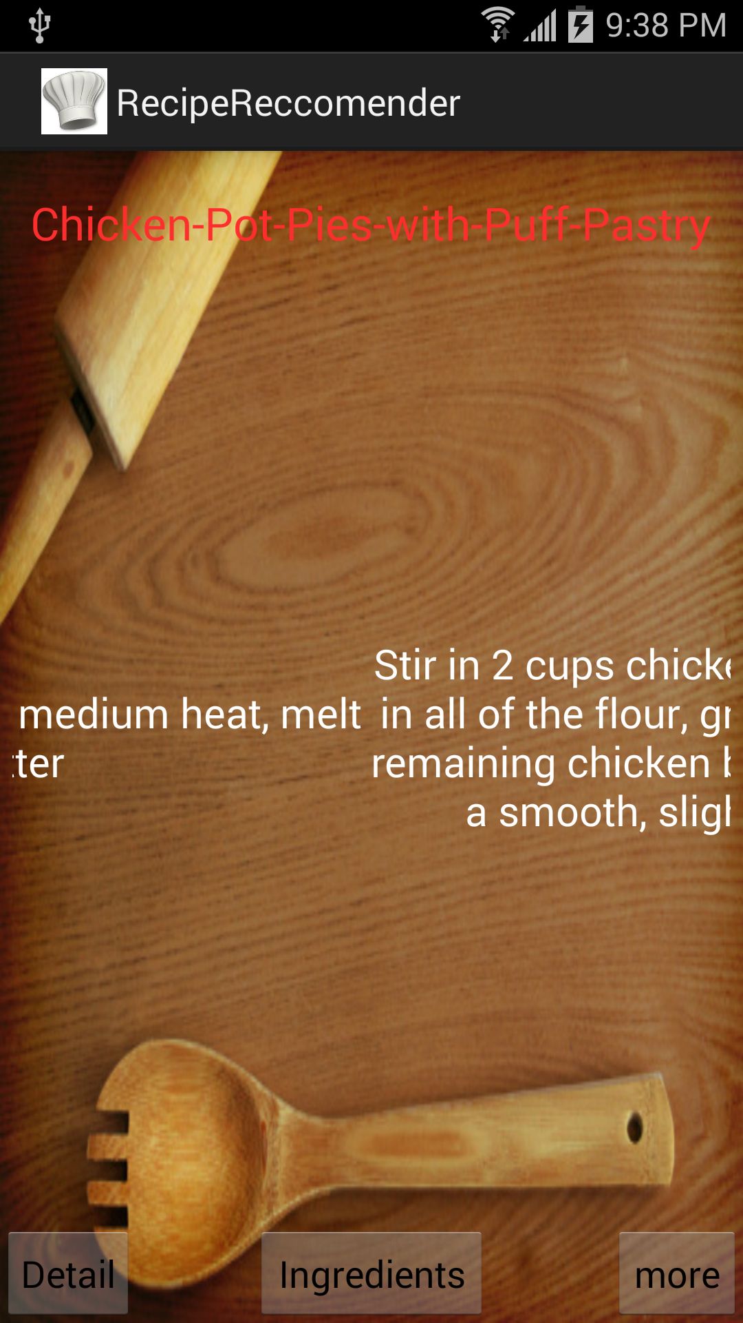

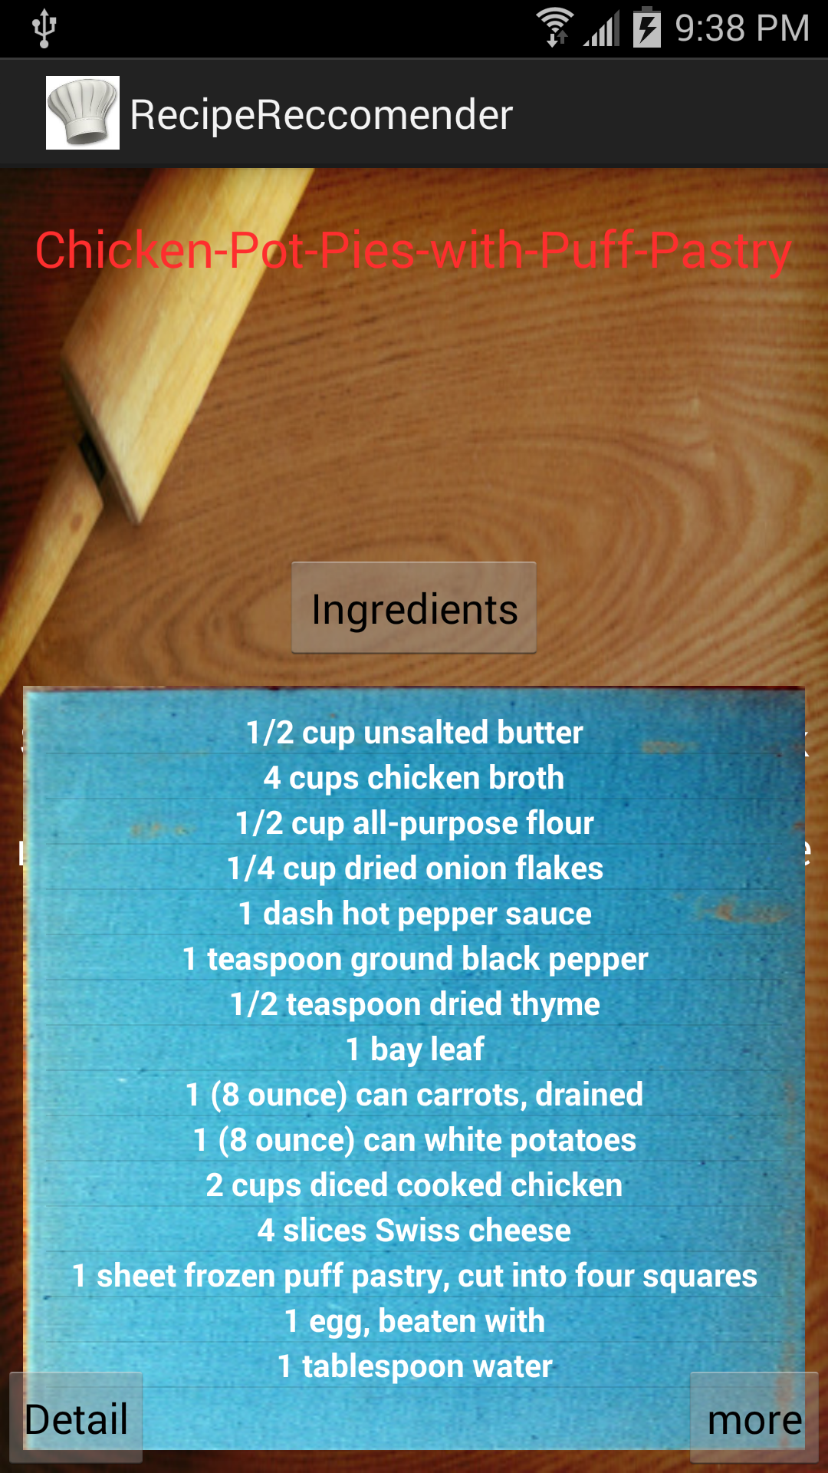 For 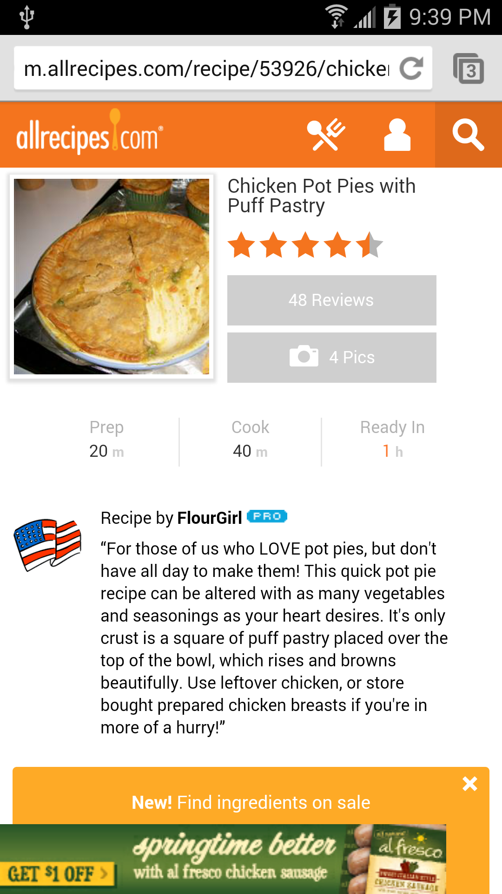

**Git Hub Repository:**

https://github.com/varunnarisetty/KDM_CS5560/tree/master/Recipe_project/Increment4

**ScrumDo:**

<http://www.scrumdo.com/projects/project/recipe-recommendation/iteration/92980>